

**PROJECT INITIATION DOCUMENT**

for

**BATTERY MANAGEMENT SYSTEM**

By

**ADEV - B2**

Under the guidance of

**Mrs. Nagma Tazeen**

**Mr. Kaushik B.K**

**Mr. Pavan Kumar E**

**RV - SKILLS CENTER FOR EMERGING TECHNOLOGIES**

**Automotive Electronics**

**INDEX**

|  |  |  |  |
| --- | --- | --- | --- |
| 1 | Aim | | 3 |
| 2 | Hardware | Battery cells | 4 |
| Voltage Sensors | 6 |
| Current Sensor | 7 |
| Temperature Sensor | 8 |
| Power Resistors | 9 |
| Power MOSFETS | 10 |
| Voltage Regulator | 11 |
| ESP8266 NODE MCU | 12 |
| Esp8266 V3 CH340 Module | 14 |
| LPC2148 Microcontroller | 15 |
| 3 | Implementation strategy | | 18 |
| 4 | Design | | 19 |
| 5 | Algorithm | | 22 |
| 6 | Flow chart | | 25 |
| 7 | Challenges faced | | 30 |
| 8 | Setting up developing environment | | 31 |
| 9 | Coding standards | | 56 |
| 10 | Program | | 57 |
| 11 | Further enhancement | | 68 |
| 12 | Bill of material | | 69 |
| 13 | Abbreviation used | | 70 |

**PROJECT TITLE**

**BATTERY MANAGEMENT SYSTEM**

## 

## **BRIEF DESCRIPTION:**

Battery management systems (BMS) are electronic control circuits that monitor and regulate the charging and discharging of batteries. The battery characteristics to be monitored include the detection of battery voltages, temperature, capacity, state of charge, Health of battery, power consumption, remaining operating time, charging cycles, Battery protection and some more characteristics.

The task of battery management systems is to ensure the optimal use of the residual energy present in a battery. BMS protect the batteries from deep discharging and over charging, which are results of extreme fast charge and extreme high discharge current which will affect the battery life. In the case of multi-cell batteries, the battery management system also provides a cell balancing function, to manage that different cell of battery.

**Hardware Description:**

**Battery cells [LI-ION 3.2V 6A]:**

A lithium-ion battery is a family of rechargeable battery types in which lithium ions move from the negative electrode to the positive electrode during discharge and back when charging.

Lithium-ion is the most popular rechargeable battery chemistry used today. Lithium-ion batteries power the devices we use every day, like our mobile phones and electric vehicles.

Lithium-ion batteries consist of single or multiple lithium-ion cells, along with a protective circuit board. They are referred to as batteries once the cell, or cells, are installed inside a device with the protective circuit board.

**Components of a lithium-ion cell:**

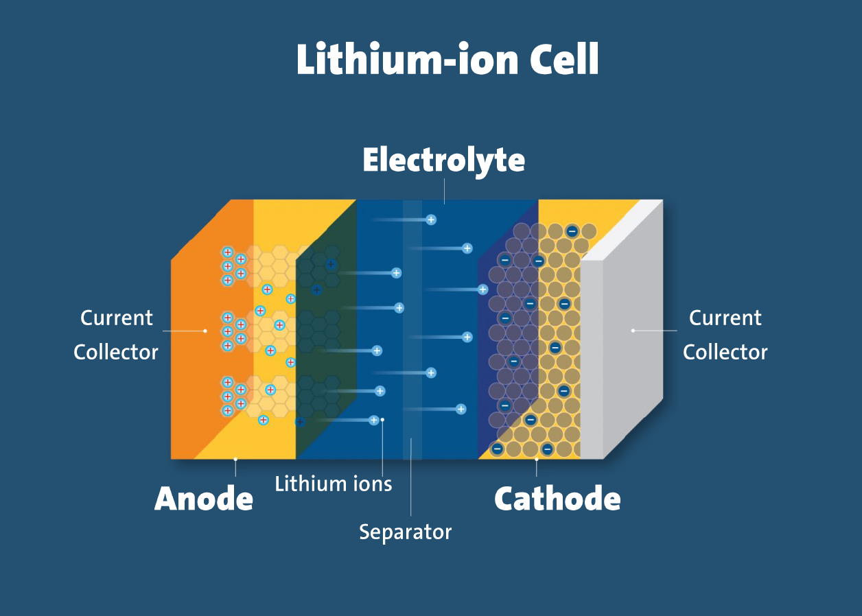

**Electrodes:** The positively and negatively charged ends of a cell. Attached to the current collectors.

**Anode:** The negative electrode.

**Cathode:** The positive electrode.

**Electrolyte:** A liquid or gel that conducts electricity.

**Current collectors:** Conductive foils at each electrode of the battery that are connected. to the terminals of the cell. The cell terminals transmit the electric current between the battery, the device and the energy source that powers the battery.

**Separator:** A porous polymeric film that separates the electrodes while enabling the exchange of lithium ions from one side to the other.

## **Lithium-ion cell working principle:**

In a lithium-ion battery, lithium ions (Li+) move between the cathode and anode internally. Electrons move in the opposite direction in the external circuit. This migration is the reason the battery powers the device—because it creates the electrical current.

While the battery is discharging, the anode releases lithium ions to the cathode, generating a flow of electrons that helps to power the relevant device.

When the battery is charging, the opposite occurs: lithium ions are released by the cathode and received by the anode.

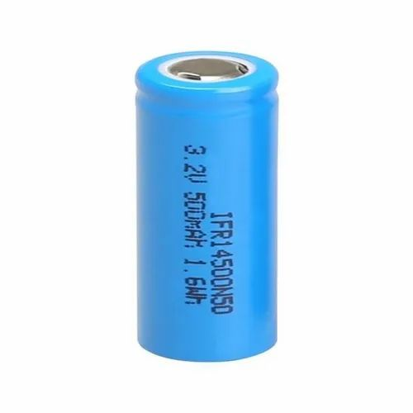

**Lithium-Ion cell**

**Voltage Sensors [EC-2173]:**

Voltage Sensor is a precise low-cost sensor for measuring voltage. It is based on principle of resistive voltage divider design. It can make the red terminal connector input voltage to 5 times smaller. The voltage detection module input voltage not greater than 5Vx5=25V (if using 3.3V systems, input voltage not greater than 3.3Vx5=16.5V).

**Features:**

* Voltage input range: DC 0-25V
* Voltage detection range: DC 0.02445V-25V
* Voltage Analog Resolution: 0.00489V
* DC input connector: Terminal cathode connected to VCC, GND negative pole
* Output interface: "+" connect 5/3.3V, "-" connect GND, "s" connect the STM32F103 AD pins.

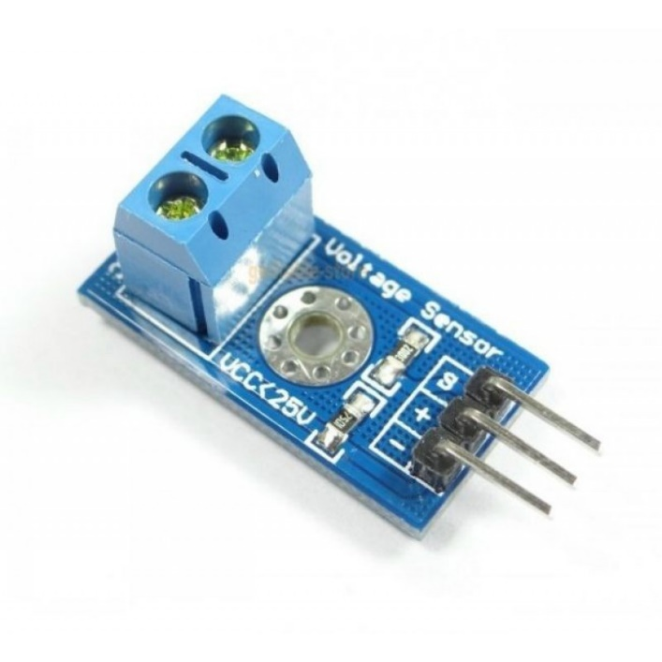

**Voltage Sensors [EC-2173]**

**Current Sensor [ACS712]:**

The ACS712 is a fully integrated, hall effect-based linear current sensor with 2.1kVRMS voltage isolation and a integrated low-resistance current conductor. Technical terms aside, it’s simply put forth as a current sensor that uses its conductor to calculate and measure the amount of current applied.

**Features:**

* 80khz bandwidth.
* 66 to 185 mv/A output sensitivity.
* Low-noise analog signal path.
* Device bandwidth is set via the new FILTER pin.
* 1.2 mω internal conductor resistance.
* Total output error of 1.5% at TA = 25°C.
* Stable output offset voltage.
* Near zero magnetic hysteresis

### **ACS712 Current Sensor work:**

 Current sensors can work either be done through direct or indirect sensing. For the ACS712, it uses indirect sensing.

For current sensors that work by direct sensing, ohm’s law is being applied to measure the drop in voltage when flowing current is detected.

Current flows through the onboard hall sensor circuit in its IC. The hall effect sensor detects the incoming current through its magnetic field generation. Once detected, the hall effect sensor generates a voltage proportional to its magnetic field that’s then used to measure the amount of current.

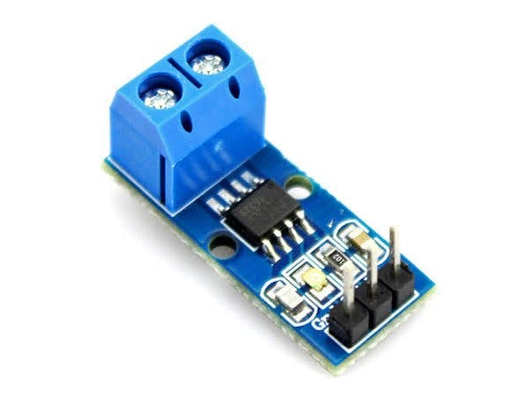

**Current Sensor [ACS712]**

**Temperature Sensor [20D9 NTC Thermistor]:**

NTC stands for "Negative Temperature Coefficient". NTC thermistors are **resistors with a negative temperature coefficient**, which means that the resistance decreases with increasing temperature. They are primarily used as resistive temperature sensors and current-limiting devices.

20D9 NTC Thermistor (NTC-Negative Temperature Coefficient), these R-T curve (Resistance-Temperature) matched thermistors are small, high quality, epoxy encapsulated, precision devices. These epoxy-coated interchangeable chip thermistors offer true interchangeability over wide temperature ranges, permitting the circuit designer to standardize circuitry. This eliminates the need to individually adjust circuits and allows the thermistors to be easily replaced without the need for re-calibration.

|  |  |
| --- | --- |
| Resistance (Ω) | 20 |
| Tolerance (%) | 1 |
| Temperature Co-efficient | NTC |
| Operating Temperature Range (°C) | -55 to 200 |
| Diameter (mm) | 9 |
| Weight (gm) | 0.5 each |
| Shipment Weight | 0.01 kg |
| Shipment Dimensions | 2 × 1 × 1 cm |

**Specifications:**

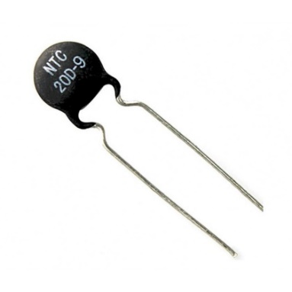

**20D9 NTC Thermistor**

**Power Resistors:**

 Power resistors are **designed to withstand and dissipate large amounts of power**. The common trait of all power resistors is that they are built to dissipate as much power as possible, while keeping their size as small as possible. In general, they have a power rating of at least 5 W. Power resistors are made from materials with a high thermal conductivity, allowing efficient cooling. They are also often designed to be coupled with heat sinks to be able to dissipate the high amounts of power. Some power resistors even require forced air or liquid cooling while under maximum load to efficiently remove the heat generated.

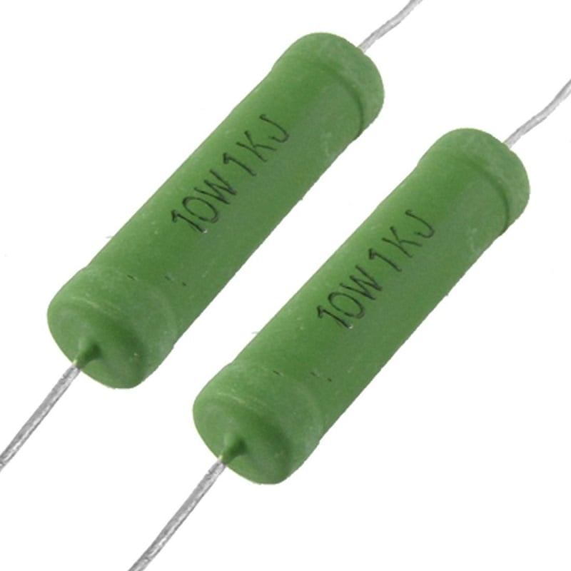

**Power Resistors**

**Power MOSFETS [IRF 540]:**

IRF540 third generation power MOSFETs provide the designer with the best combination of fast switching, ruggedized device design, low on-resistance and cost-effectiveness. The TO-220AB package is universally preferred for all commercial-industrial applications at power dissipation levels to approximately 50 W.

**Features:**

• Dynamic dV/dt rating

• Repetitive avalanche rated

• Fast switching

• Ease of paralleling

• Simple drive requirements

• Compliant to RoHS directive 2002/95/EC

|  |  |
| --- | --- |
| **Number of Channels** | 1 Channel |
| **Transistor Polarity** | N-Channel |
| **Drain-Source Breakdown Voltage (Vds)** | 100V |
| **Continuous Drain Current (Id)** | 33A |
| **Drain-Source Resistance (Rds On)** | 44mOhms |
| **Gate-Source Voltage (Vgs)** | 20V |
| **Gate Charge (Qg)** | 71 nC |
| **Operating Temperature Range** | -55 - 175°C |
| **Power Dissipation (Pd)** | 130W |

**Detailed Specifications:**

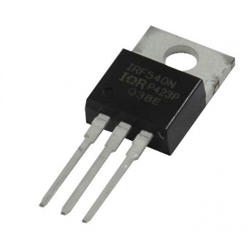

**Power MOSFETS [IRF 540]**

**Voltage Regulator [LM7805]:**

The LM7805 is a voltage regulator that outputs +5 volts.

Like most other regulators in the market, it is a three-pin IC; input pin for accepting incoming DC voltage, ground pin for establishing ground for the regulator, and output pin that supplies the positive 5 volts

**Product Features:**

* 3-Terminal Regulators
* Output Current up to 1.5A
* Internal Thermal-Overload Protection
* High Power-Dissipation Capability
* Internal Short-Circuit Current Limiting
* Output Transistor SAFE-Area Compensation

**Absolute Maximum Input Voltage**

* 35V

**Recommended Operating Conditions**

* Input Voltage: Minimum 7V, Maximum 25V
* Output Current: 1.5A
* Operating Virtual Junction Temperature: Minimum 0, Maximum 125°C

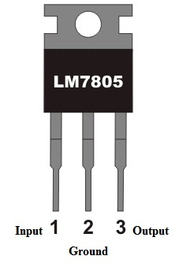

**LM7805 IC**

**ESP8266 NODE MCU:**

The ESP8266 is a low-cost Wi-Fi microchip, with built-in TCP/IP networking software, and microcontroller capability.

All ESP8266 variants have a ESP8266EX core processor and a Tensilica L106 32-bit micro controller unit. This is a low cost, high performance, low power consumption, easy to program, wireless SoC (System-On-Chip). It provides capabilities for 2.4 GHz Wi-Fi (802.11 b/g/n, supporting WPA/WPA2), general-purpose input/output (13 GPIO), Inter-Integrated Circuit (I²C), analog-to-digital conversion (10-bit ADC), Serial Peripheral Interface (SPI), I²S interfaces with DMA (sharing pins with GPIO), UART (on dedicated pins, plus a transmit-only UART can be enabled on GPIO2), and pulse-width modulation (PWM).

It has a build-in programmer and a voltage regulator, that allow flashing and powering the device via micro-USB. The system operates at 3.3V.

## **Specifications:**

* Tensilica L106 32-bit micro controller unit at 80 MHz (or overclocked to 160 MHz)
* 32 kB instruction RAM
* 80 kB user data RAM
* 16 kB ETS system data RAM
* Flash Memory 4Mb
* USB – micro-USB port for power, programming and debugging
* 13 GPIO pins
* 802.11 b/g/n, supporting WPA/WPA2
* STA / AP modes support
* TCP / IP protocol stack, One socket
* TCP / UDP Server and Client
* Pin-compatible with Arduino UNO, Mega
* KEY button: modes configuration
* 32-bit hardware timer
* WiFi operation current: continuous transmission operation: ≈70mA (200mA MAX), deep sleep mode: <3mA
* Serial WiFi transmission rate: 110-460800bps
* Temperature: -40℃ ~ + 125 ℃
* Humidity: 10%-90% non-condensing
* Weight: about 20g (0.7oz)
* Pulse-Width Modulation (PWM)
* Interrupt capability
* 3.3V operating voltage, internal voltage regulator allows 5V on power input
* maximum current through GPIO pins: 12mA (source), 20mA (drain)
* available firmware for Arduino IDE
* WebSocket libraries available

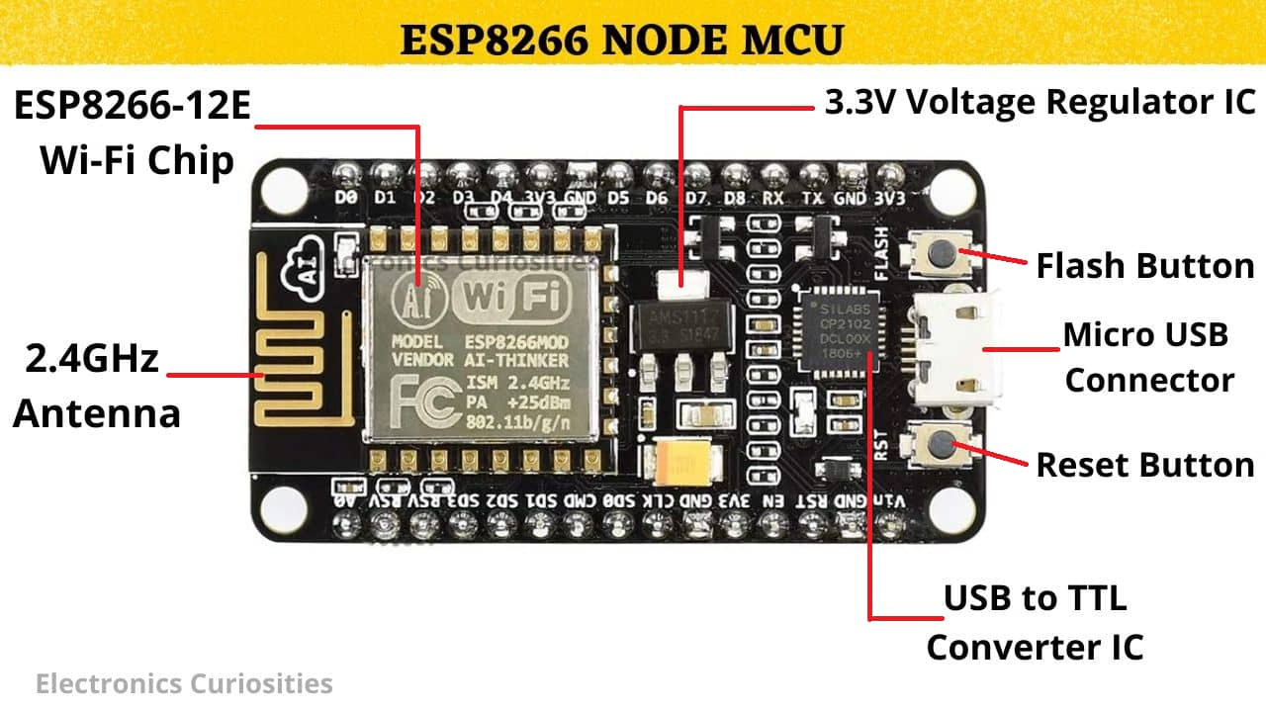

**ESP8266 NODE MCU:**

**Esp8266 V3 CH340:**

CH340 ESP8266 NodeMcu ESP 8266 V3 CH340 Lua WIFI Internet Of Things Development Lolin Board Based ESP8266 CH 340 Wireless Module ESP-12E Electronics Circuitry & Parts. ESP8266MOD or ESP-12E or ESP-12F is New Lolin NodeMcu Lua V3 Wireless Module Wifi Internet of Things (IoT) Development Board Based on ESP8266 Micro USB To TTL

### **Specifications & Features:**

* Wireless 802.11 b / g / n standard
* Support STA / AP / STA + AP three operating modes
* Built-in TCP / IP protocol stack to support multiple TCP Client connections (5 MAX)
* D0 ~ D8, SD1 ~ SD3: used as GPIO, PWM, IIC, etc., port driver capability 15mA
* AD0: 1 channel ADC
* Power input: 4.5V ~ 9V (10VMAX), USB-powered
* Current: continuous transmission: ≈70mA (200mA MAX), Standby: <200uA
* Transfer rate: 110-460800bps
* Support UART / GPIO data communication interface
* Remote firmware upgrade (OTA)
* Support Smart Link Smart Networking
* Working temperature: -40 ℃ ~ + 125 ℃
* Drive Type: Dual high-power H-bridge driver

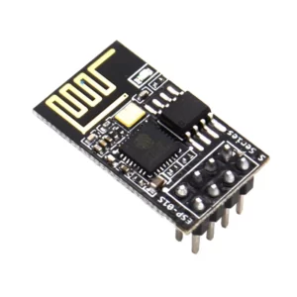

**Esp8266 V3 CH340**

**LPC2148 Microcontroller:**

ARM7 LPC2148 Development Board is a powerful development platform based on LPC2148 ARM7TDMI microcontroller with 512K on-chip memory. This board is ideal for developing embedded applications involving high speed wireless communication, USB based data logging, real time data monitoring and control, interactive control panels etc. The on-chip USB controller provides direct high speed interface to a PC/laptop with speeds up to 12Mb/s. The UART boot loader eliminates need of an additional programmer and allows you to program using serial port. The on board peripherals include SD/MMC card interface, USB2.0 interface, 4Kbit I2C EEPROM, Xbee wireless module interface, ULN2003 500mA current sinking driver, L293D DC motor controller, 16X2 character LCD and many more. The on-chip peripherals and the external hardware on the development board are interconnected using pin headers and jumpers. The I/O pins on the microcontroller can be accessed from a 50 pin male header. The board is made from double sided PTH PCB board to provide extra strength to the connector joints for increased reliability. It supports the operating supply voltage between 7V to 14V and has built-in reverse polarity protection.

**Specifications:**

* Microcontroller: LPC2148 with 512K on chip memory.
* Crystal for LPC2148: 12Mhz.
* Crystal for RTC: 32.768KHz.
* 50 pin Berg header for external interfacing.
* Operating Supply: 9V DC/AC.
* 2.4GHz ZigBee (XBee) wireless module adaptor.
* 512 bytes of I2C external EEPROM.
* USB Type B Connector.
* SD / MMC card holder.
* 10pin(2X5) FRC JTAG connector for flashing and debugging.
* 50 Pin Expansion header.
* 2x16 Character Alphanumeric LCD.
* L293D 600mA Dual DC motor Driver.
* ULN2003 500mA driver.
* Dual RS232 UARTs for external communication.
* Real-Time Clock with Battery Holder.
* 2 Analog Potentiometers connected to ADC.
* TSOP1738 IR receiver.
* 4 USER Switches.
* 4 USER LEDs.
* Reset and Boot loader switches.
* 3V button cell for on chip RTC.
* ON/OFF switch.
* Buzzer

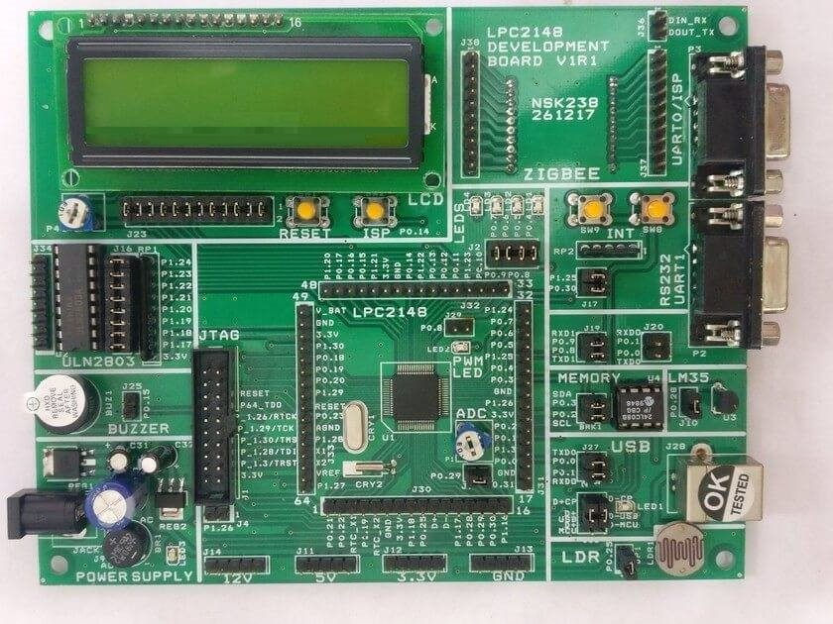

**LPC2148 Microcontroller pinout diagram:**

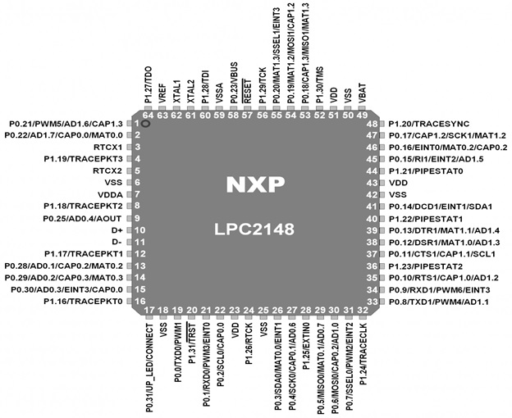

**IMPLEMENTATION STRATEGY:**

**Design 1: Developing a BMS system from component level.**

**Design 2: Interfacing of BMS module with Battery pack.**

**Phase1 for Design 1:**

1. Designing a battery pack of 24V with 20Ah.
2. Measuring individual Cell voltages in battery pack.
3. Calculating total voltage and current of battery pack.
4. Monitoring the temperature of the battery pack.
5. Battery Low indication.
6. Battery Full indication.
7. Display the above parameters on GUI (mobile app).

**Phase 2 Design 1:**

1. Calculating SOC.
2. Calculating SOH.
3. Cell balancing of battery pack.

**Design 2:**

1. Designing a battery pack of 24V with 20Ah.
2. Interfacing of BMS module with battery pack.
3. Reading the SOC and SOH value from BMS and display on the system.
4. Monitoring the temperature of battery pack.
5. Battery Low indication.
6. Battery Full indication.
7. Display the above parameter on GUI (mobile app).

#### **RESOURCE PLANNING:**

**Design1:**

1. Li-ion cells battery pack.
2. STM32 controller which supports CAN protocol (STM32F103C6).
3. Voltage, Current and Temperature sensors.
4. Wi-Fi module.
5. Cell balancing and monitoring circuit.
6. Battery protection circuit.

### **Design2:**

1. Li-ion cells battery pack.
2. BMS module.
3. STM32 controller which supports CAN protocol (STM32F103C6).
4. Wi-Fi module.

**We are implementing design 1 for our project.**

As part of our project, we have designed a battery pack of 25.6V 18 A.

It will give the power output of 460Watt (P=VI).

To design the above specification, we have used Li-ion battery cell (3.2v,6A) of 24 cells.

In this Battery pack we have arranged 3 cells in parallel(stacks) such that each stack will give us 3.2V 6A, 8 stacks are arranged in series.

Overall, in this battery pack we are getting 25.6V 18A.

power output is 460W.

**Initial BMS prototype:**



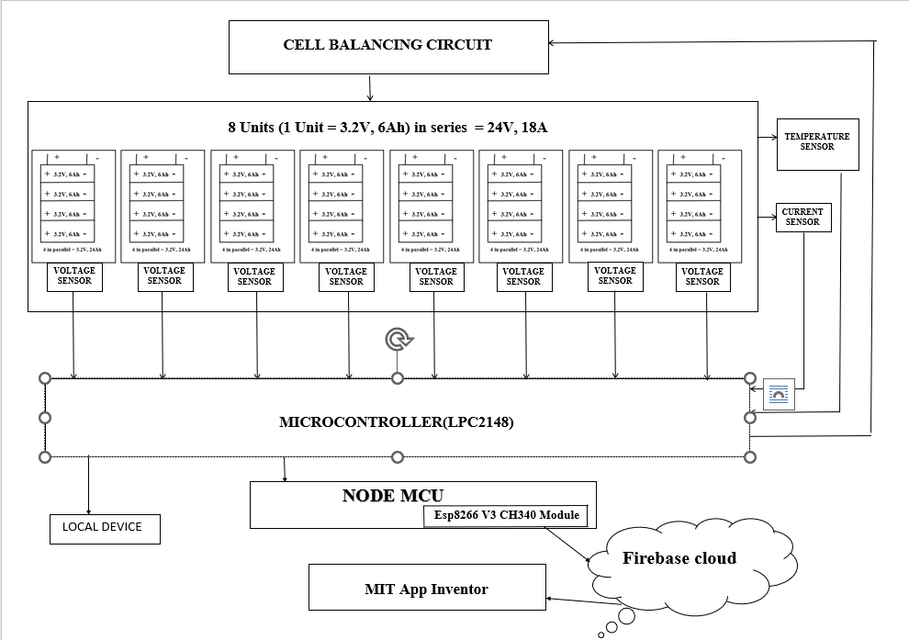

**Detailed design:**

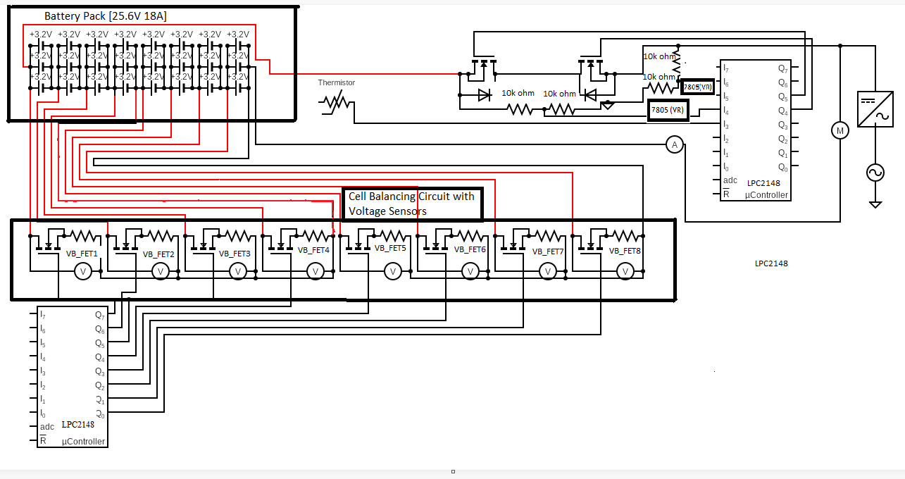



**BMS Algorithm:**

(Please refer the INDEX on the last page for elaboration of the abbreviations used).

Step 1: Start by displaying Hello message.

Step 2: Read individual voltages from all voltage sensors (Voltage monitoring function).

Step 3: While Charger is not connected, and Battery is connected.

Step 4: If any of the cell voltage is <=2.9 display low charge warning message, turn off D-Relay and exit.

Step 5: Else call the discharge function where power is supplied continuously to the load till the cells discharge up to 2.9V.

Step 6: Call voltage monitoring function.

Step 7: While charger is connected, and voltages of cells are <=3.65V.

Step 8: Call charger function where the C-Relay is turned ON and Cell balancing function is called.

**Voltage Monitoring:**

1. Continuously read the analogue output of Voltage sensors into the ADC of STM32.

2. Voltage V1=Vs1-Vs2 (Vs is Voltage read by the sensor) V2=Vs2-Vs3 V3=Vs3-Vs4 V4=Vs4 V5=Vs5-Vs6 V6=Vs6-Vs7 V7=Vs7-Vs8 V8=Vs8 Vt=Vs1 (Vt is the Total voltage of the battery pack).

3. Display individual cell voltages along with Vt.

**Discharge Function:**

Let’s consider the pin connected at source of C- Relay as Dp.

1. Call voltage monitoring function ().

2. While Dp==1 && V1>2.9 && V2>2.9...........V8>2.9{

3. Set o/p pin connected to D- Relay.

4. Call voltage monitoring function ().

5. If (V1<=2.9 or V2<=2.9 or............V8<=2.9) {

6. Display LOW CHARGE WARNING!

7. Clear output pin connected to D- Relay (Discharging Relay).

8. Exit.}}

**Charger Function:**

Let’s consider the pin connected at source of D- Relay as Cp.

1. Set output pin connected to C- Relay (Charging Relay).

2. Call cell balancing function.

3. Clear output pin connected to C- Relay (Charging Relay).

4. Exit.

**Cell Balancing Function:**

Assign the gates in parallel to voltage sensors as G1, G2, …. G8 for V1, V2, …. V8 respectively.

1. While V1>=3.65 or V2>=3.65 or...........V8>=3.65.

2. Call voltage monitoring function ().

3. while(v1> all other cells) {Turn on gate associated with v1}

4. while(v2> all other cells) {Turn on gate associated with v2}

5. while(v3> all other cells) {Turn on gate associated with v3}

!!!

6. while(v8> all other cells) {Turn on gate associated with v8}

**Main Function:**

1. Display(“Hello!!!”).

2. While (1).

3. Call voltage monitoring function ().

4. While Cp! =1&& Dp==1. {

5. If (V1<=2.9 or V2<=2.9 or............V8<=2.9). {

6. Display LOW CHARGE WARNING!

7. Clear output pin connected to D- Relay (Discharging Relay).

8. Exit.}

9. Call Discharge function ().}

10. Clear output pin connected to D- Relay (Discharging Relay).

11. Call voltage monitoring function ().

12. while Cp==1 and V1<=3.65 and V2<=3.65 and...........V8<=3.65.

13. Call Charger function ().

14. After coming out of the while loop Clear o/p connected to C- Relay.

15. Call voltage monitoring function ().

16. If 3.65<V1<V2<v3<V8.

**Flowcharts:**

**Voltage Monitoring Function:**

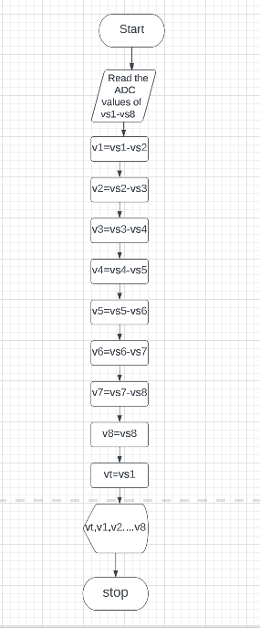

**Discharging function:**

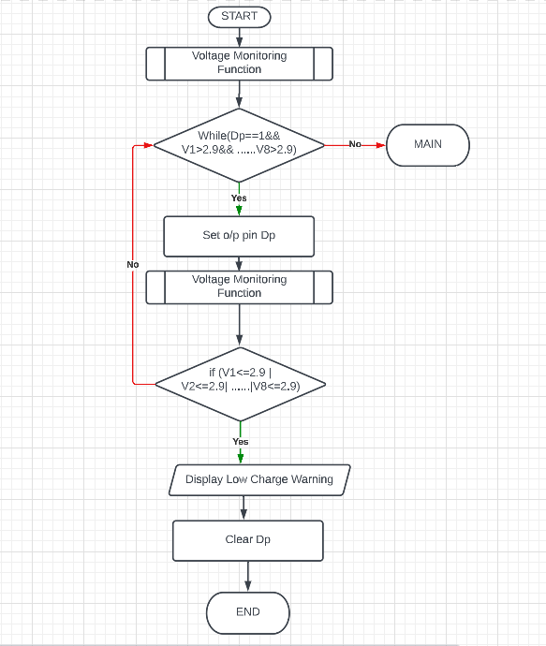

**Charger Function:**

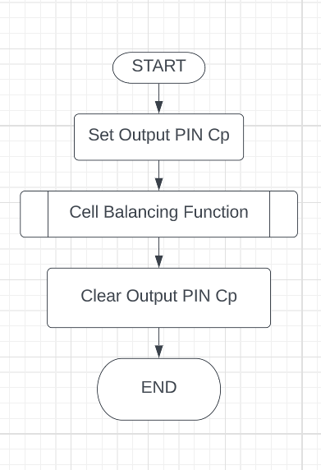

**Cell Balancing Function:**

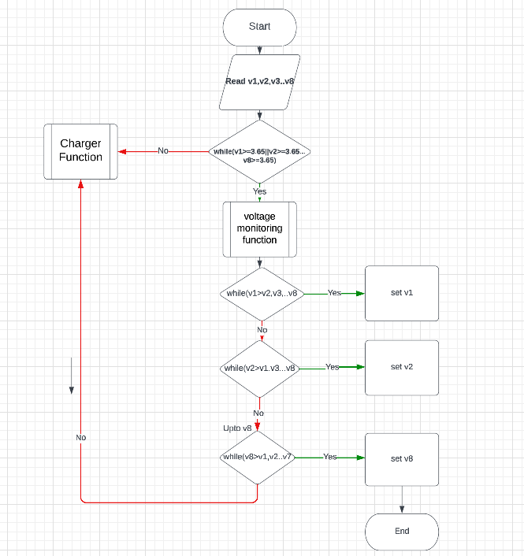

**Main Function:**

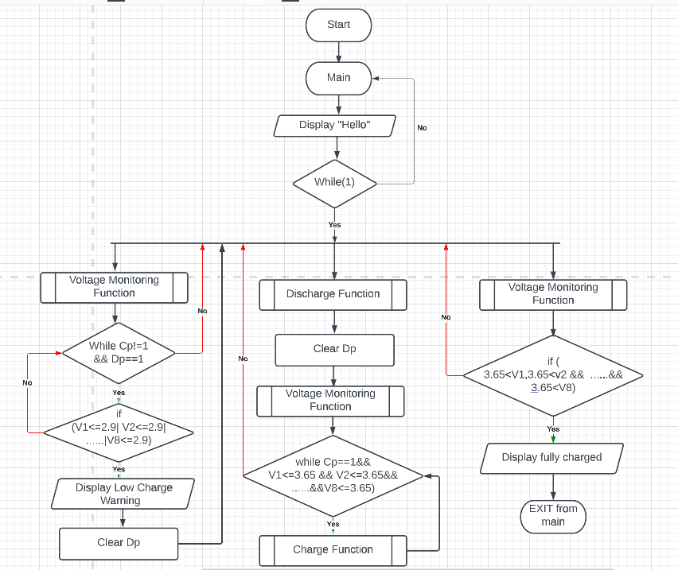

**Challenges faced:**

**Challenges faced:**

**Reading the individual stack voltages**: Voltage sensor can take a maximum input voltage of 25V but the voltage of the battery pack could go all the way till 30-32 volt.

**Balancing:** One of the main challenges in BMS is balancing the cells in a battery pack. Each cell can have a slightly different capacity or state of charge, which can cause some cells to discharge faster than others. BMS must ensure that all cells in the pack are balanced, which requires monitoring the voltage and current of each cell and redistributing the energy as needed.

**Communication and data management**: BMS must communicate with other systems and devices to ensure proper battery operation. This includes monitoring the battery's status, sending alerts and warnings, and controlling the battery's charging and discharging processes.

Data from database was not going to mobile app as the location of db was not default (us- central).

Initially when tested with stm32, we did not get proper data in UART due to mismatch of baudrate.

**Setting up developing environment:**

## **Configuring the Hardware:**

# **Step1.** The first thing to do is to install **Keil uVision IDE.**

**Step2.** After installation**,** Open Keil µVision from the icon created on your desktop.

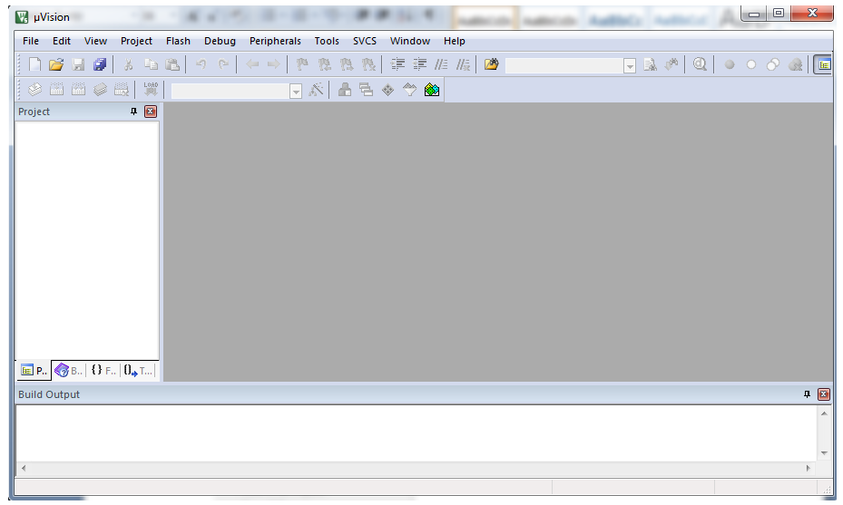

**Step3.** Go to the **Project** tab. Select New **µVision Project ...**from that menu.

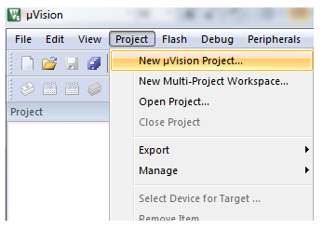

**Step4.** Create New Project window will pop up. Select the folder where you want to create project and give a suitable name to the project. Then click on Save.

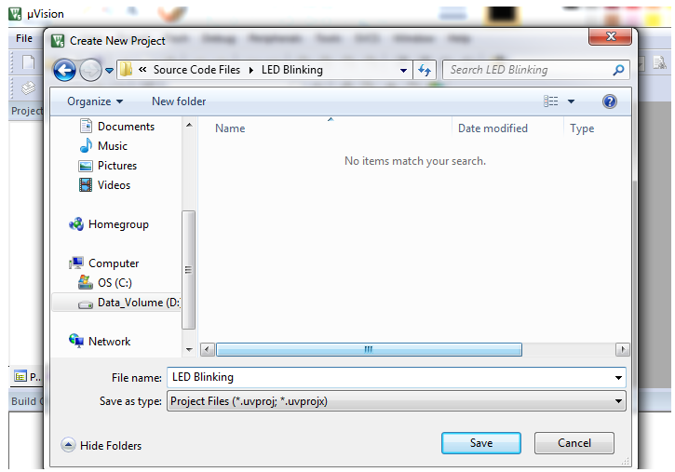

**Step5. Select Device for Target: ‘Target1’...**window will pop up next. It has a select window to choose between Software Packs or Legacy Device Database. As LPC2148 is in Legacy Device Database, choose Legacy Device Database.

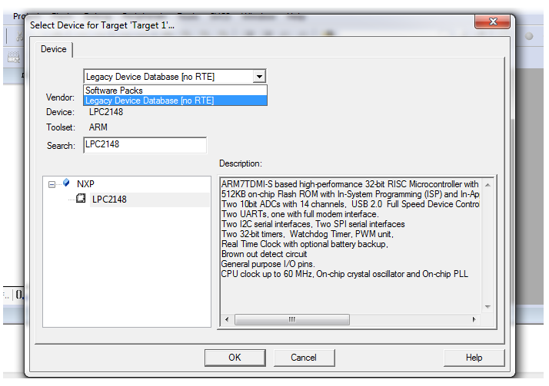

**Step6.** Type in LPC2148 in search and select the device under NXP with the name LPC2148 and click on OK.

A window will pop up asking whether to copy Startup.s to project folder and add file to project. Click on **Yes.**



**Step7.** The project name and its folders can be seen on the left side in the project window after the previous step is completed as shown below.

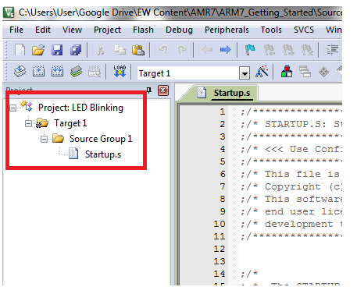

**Step8.**   Now go to File tab and add **New** file from the menu.

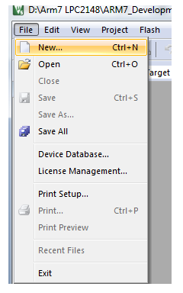

**Step9.** Save the file from the previous step with a specific name. Add .c extension to the file name.

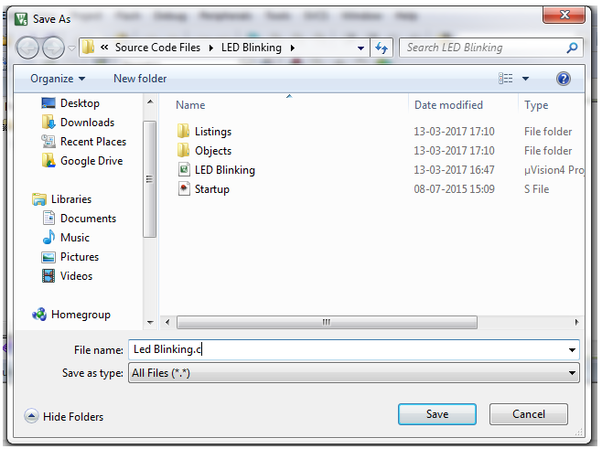

**Step10.**Add this file to Source Group folder in the project window by right clicking on Source Group1 folder and selecting Add Existing Files to Group ‘Source Group1’...

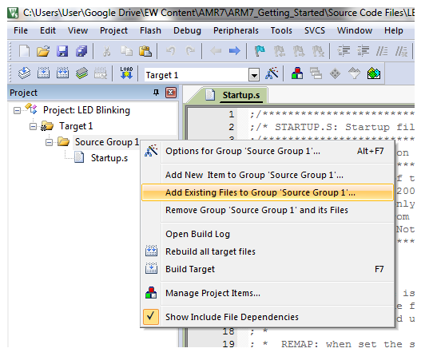

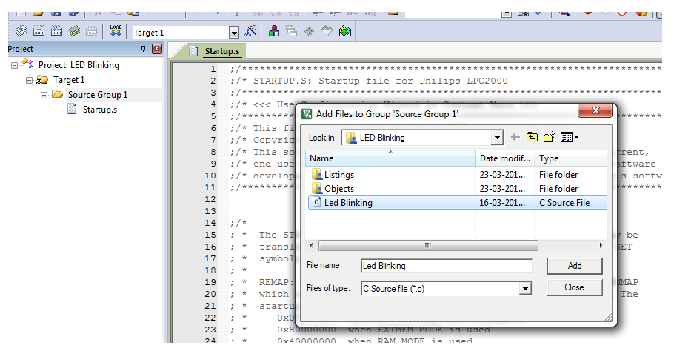

Select the previously saved file from the window that pops up and add it to the Source Group1. In our case, LED Blinking.c

**Step11.** Now click on the **Options for Target ‘Target1’...** symbol shown in red box in the image below or press **Alt+F7** or right click on Target1 and click on **Options for Target ‘Target1’...**.

Options for target window will open. Go to the **Output** tab in that window. Tick ‘√’ **Create HEX File** option. We need to produce HEX file to burn it into the microcontroller.

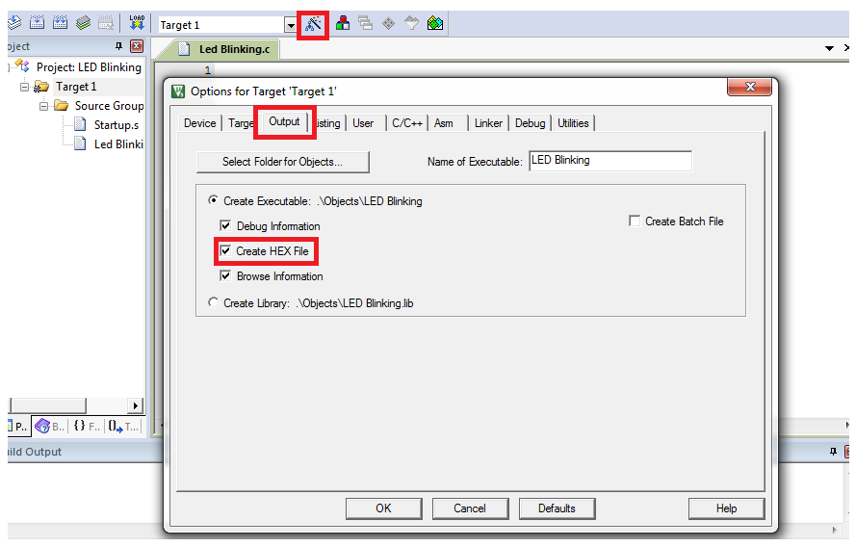

**Step12.** In the options for target window, go to the **Linker** tab. Select the **Use Memory Layout from Target Dialogue** option.

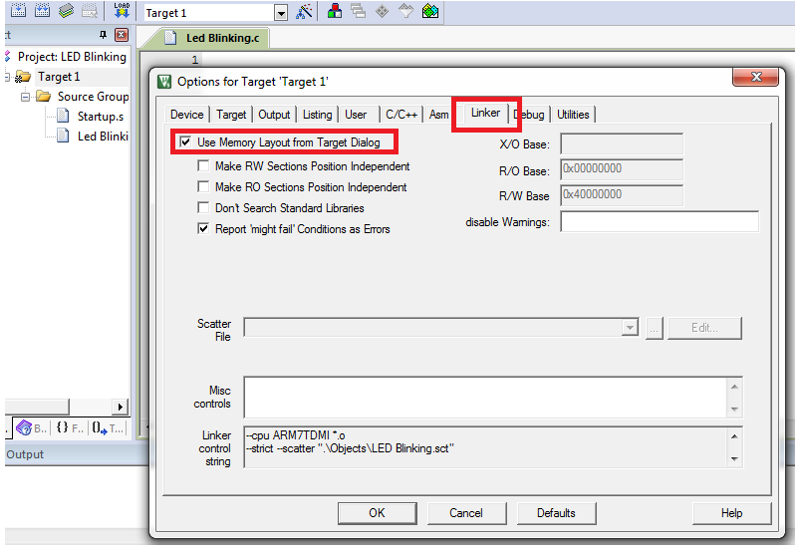

**Step13.** Now write the code for Respective application.

**Step14.** Once the code is written, **Build**the code by clicking on the button shown in red in the image below. You can also build the project from the **Build Target**option in the Project tab or by pressing **F7** on the keyboard.

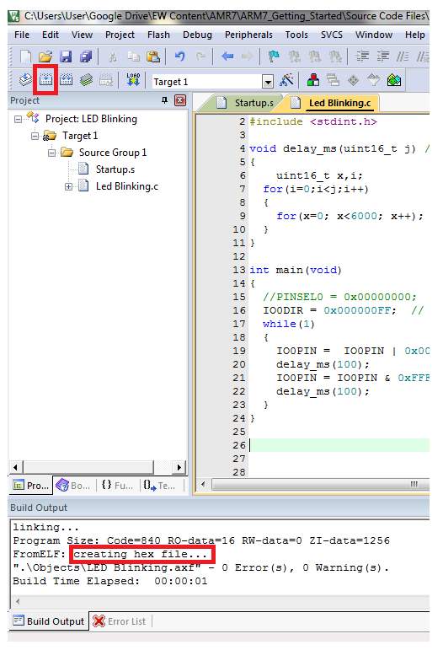

You can see **creating hex file ...**in the Build Output window as shown in the image.

**Step15.** Once the project is built, a **hex file** is created in the **Objects** folder inside the folder of your project.

**Step16.** Install the Flash Magic software to upload the code into the microcontroller.

**Step17.** Do the settings showed in the below in **Flash Magic**software to burn this hex file in your microcontroller.

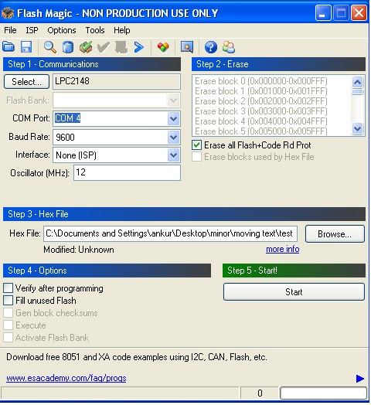

**Step18.** Click on start icon to upload the program to the microcontroller.

**Google Firebase:** The Firebase Realtime Database is **a cloud-hosted NoSQL database that lets you store and sync data between your users in realtime**. NEW: Cloud Firestore enables you to store, sync and query app data at global scale.

#### **Collaborate across devices with ease:** Realtime syncing makes it easy for your users to access their data from any device: web or mobile, and it helps your users collaborate with one another.



#### **Build serverless apps:** Realtime Database ships with mobile and web SDKs so you can build apps without the need of servers. You can also execute backend code that responds to events triggered by your database using [Cloud Functions for Firebase](https://firebase.google.com/products/functions).



**Optimized for offline use:**

When your users go offline, the Realtime Database SDKs use local cache on the device to serve and store changes. When the device comes online, the local data is automatically synchronized.



#### **Strong user-based security:**

The Realtime Database integrates with Firebase Authentication to provide simple and intuitive authentication for developers. You can use our declarative security model to allow access based on user identity or with pattern matching on your data.



**Creating a database in firebase**

**Step1.** Go to firebase.google.com> Sign in using your G-mail account> go to console.



**Step2.** Add a project in the console&gt; Enter the name for the project&gt; continue&gt; continue&gt; select the google

analytics account&gt; create project&gt; click continue on successful creation of the project.

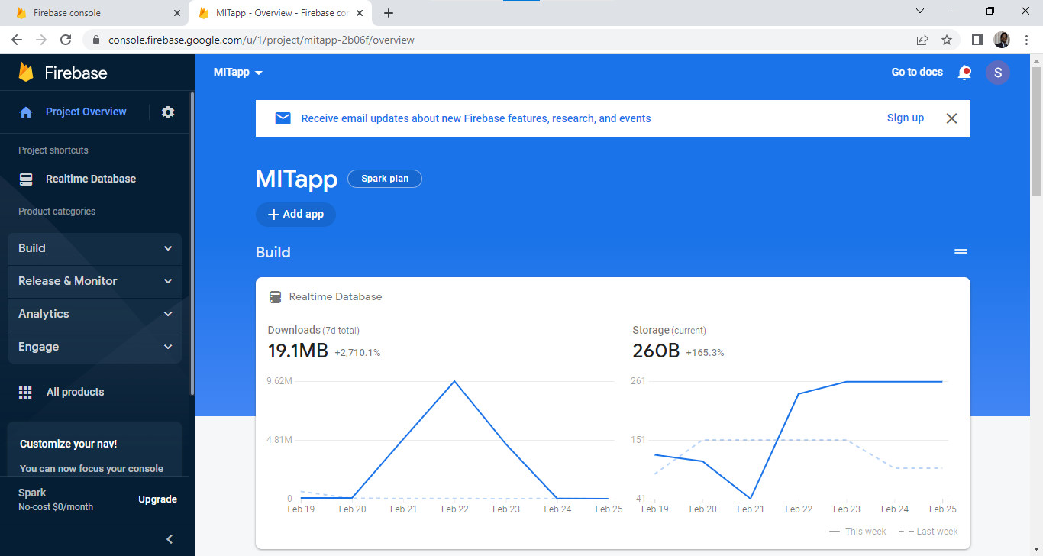

**Step3.** In the project overview> go to project settings in the top left> go to service accounts> database secrets> Here we get the API key for the particular database project. It is required in Arduino scripting.

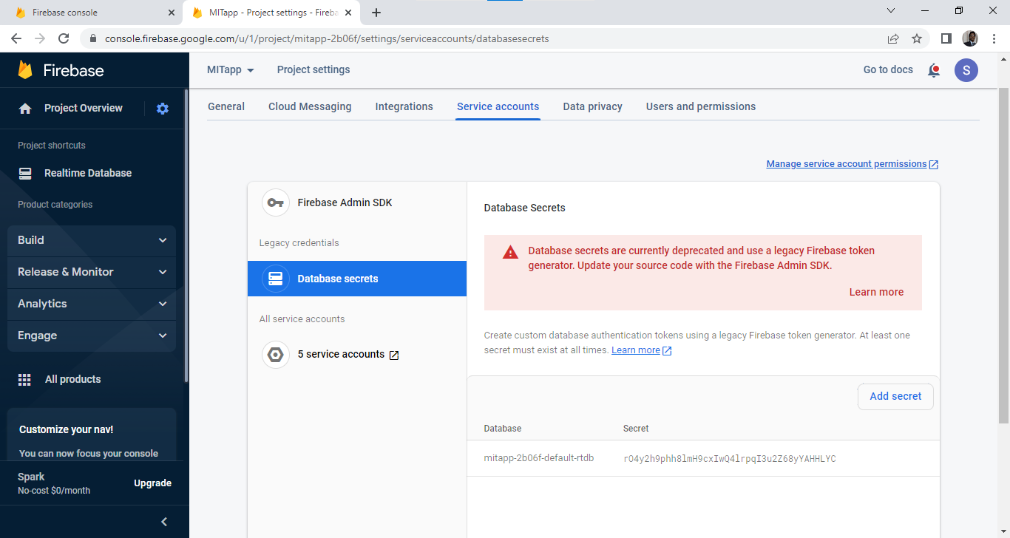

**Step4.** Click on realtime database on the left side> create database> start in test mode> next> Select Database location (default us-central)> done.

Security rules> start in test mode> enable

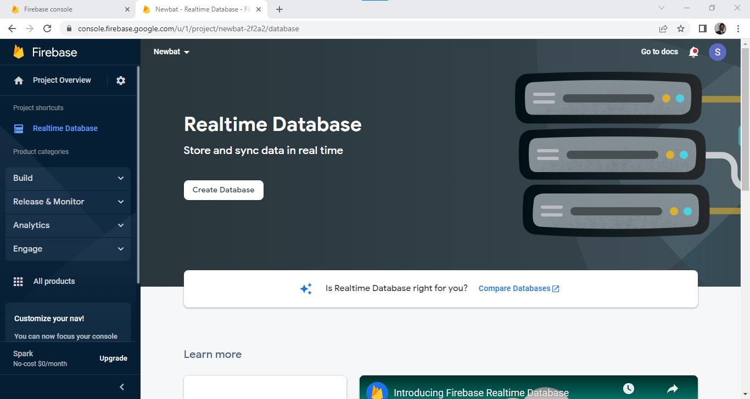

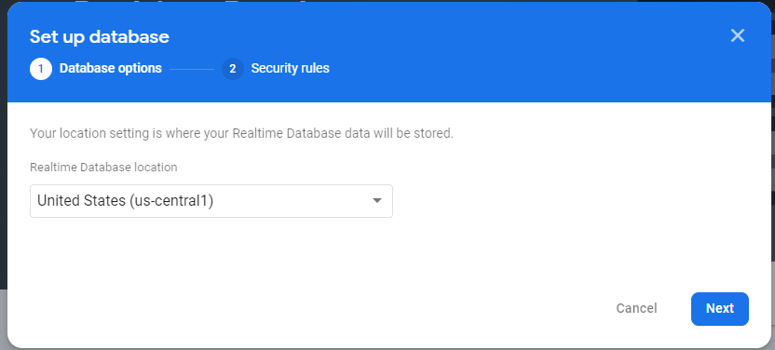

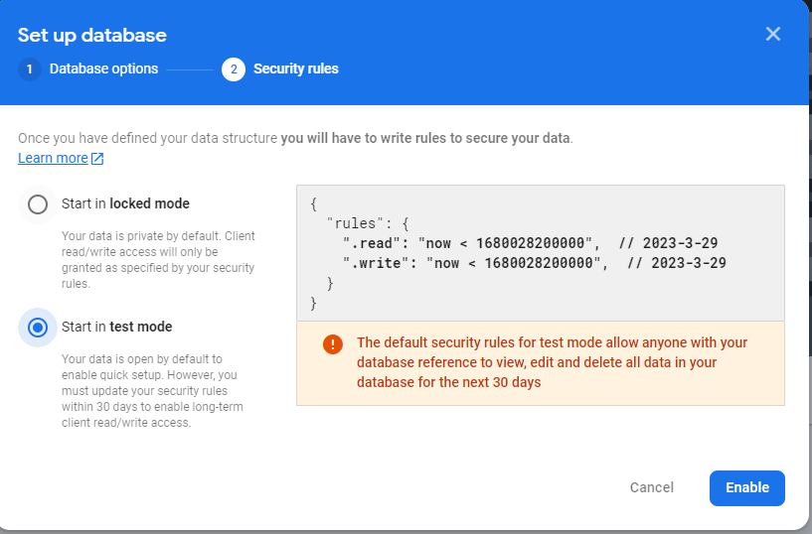

**Step5.** Go to build in left corner> real time database> copy the database URL for Arduino scripting.

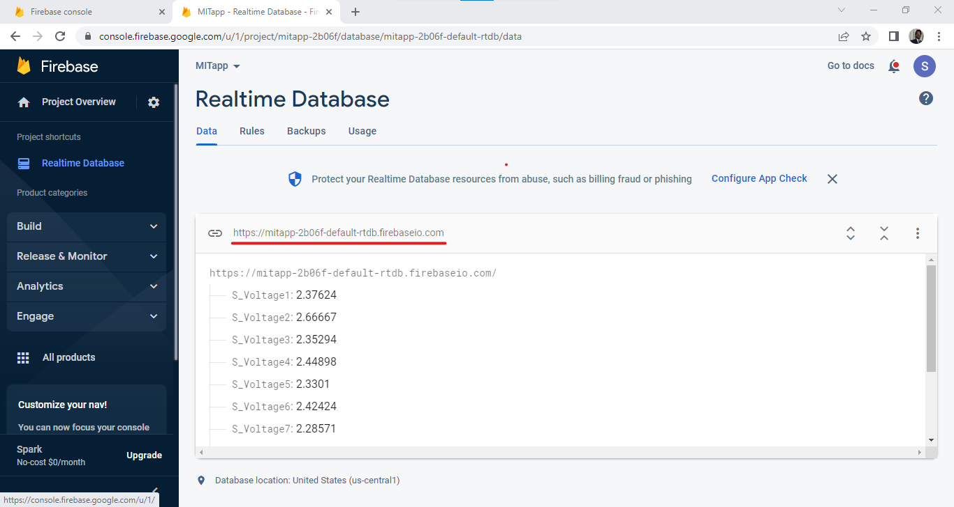

**Step6.**Need to change the rules for read and write as true> publish.

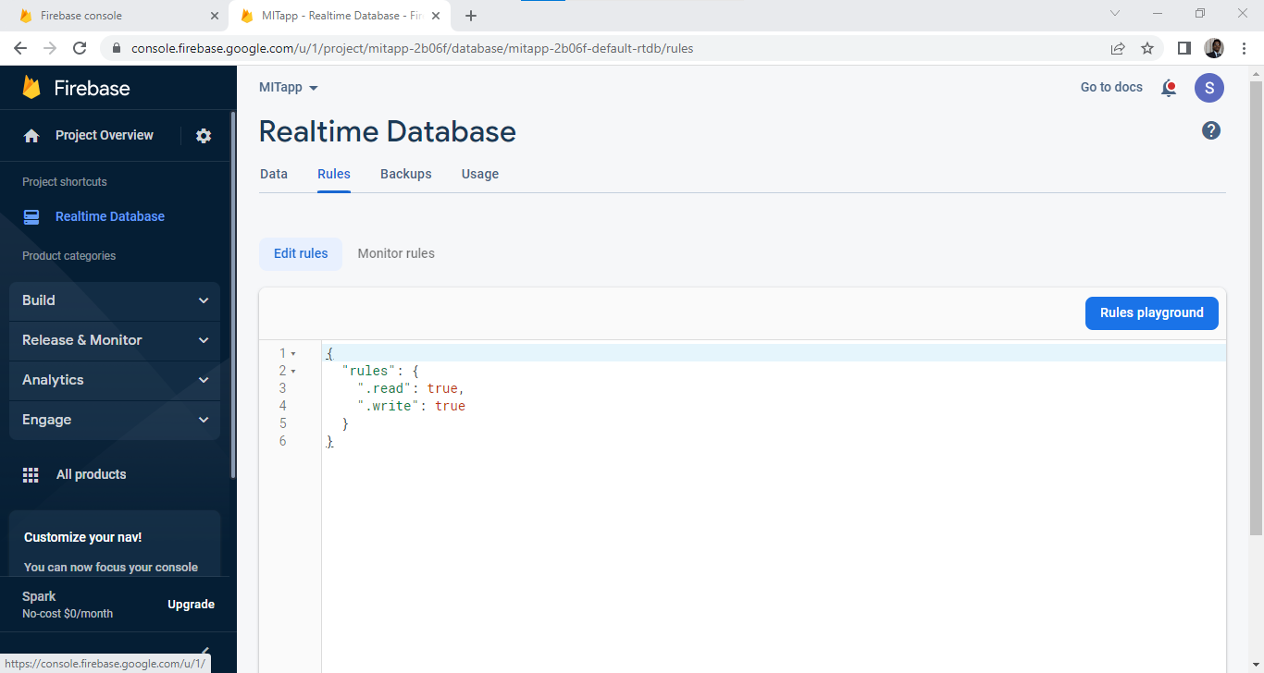

**Node MCU (ESP8266) programming:**

**Step1.** In the Arduino IDE> open new file> go to file> preferences> paste this URL http://arduino.esp8266.com/stable/package_esp8266com_index.json in the additional board manager> OK

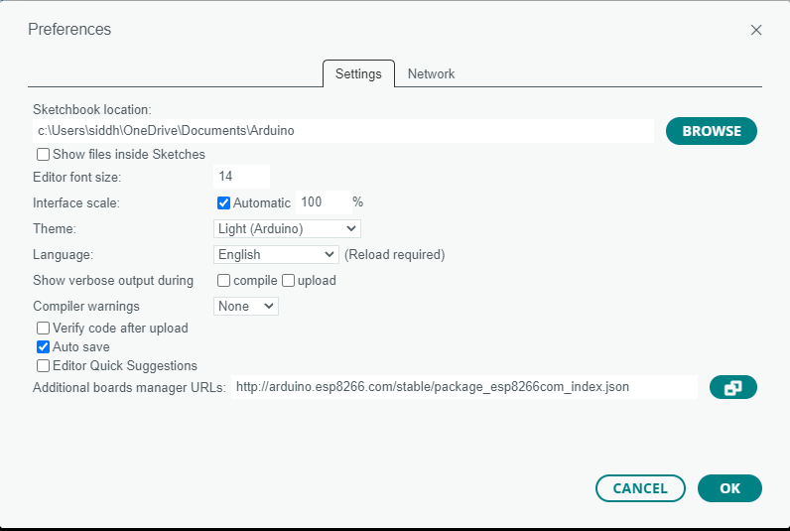

**Step2.** Go to Firebase Arduino library> download the zip file> go to this link [https://github.com/FirebaseExtended/firebase-arduino>](https://github.com/FirebaseExtended/firebase-arduino%3e) go to codes> download ZIP.

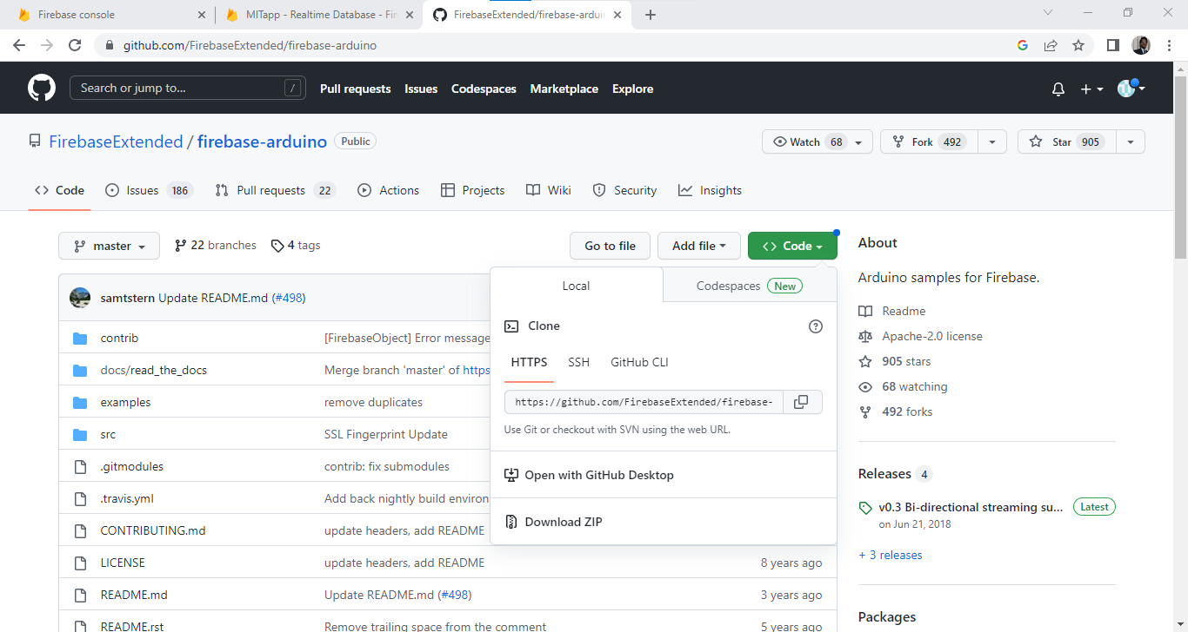

**Step3.** Go to documents> Arduino> libraries> copy this file in this folder and extract.

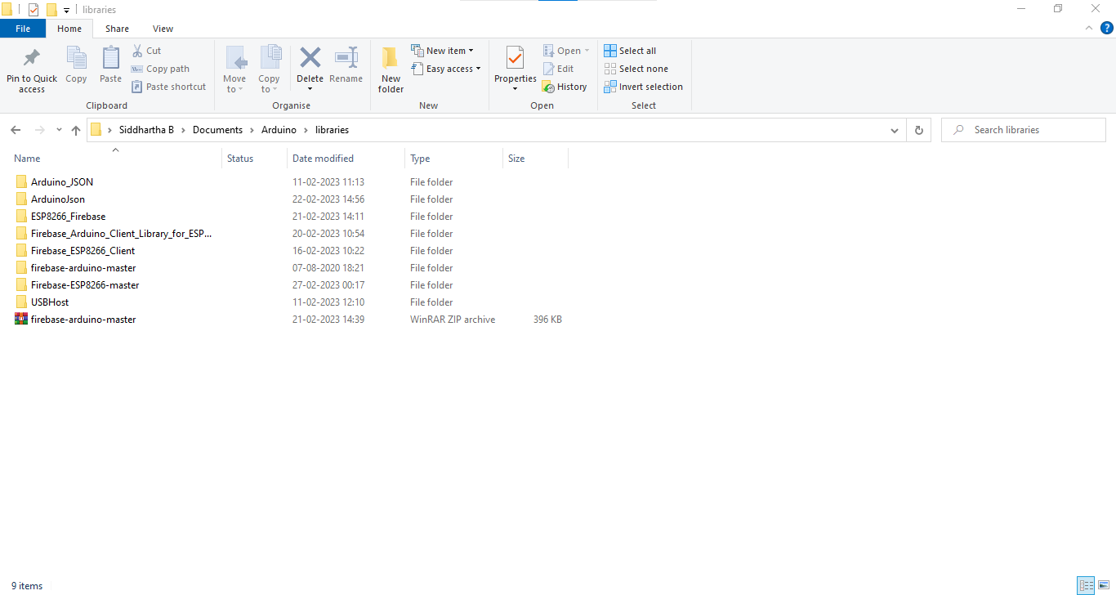

**Step4.** In the Arduino IDE> tools> manage libraries> search for arduino json> install the version above 5.13.1

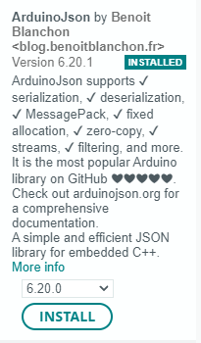

**Step4.** Install the ESP8266 firebase v1.1.0 library, firebase arduino client library for ESP8266.

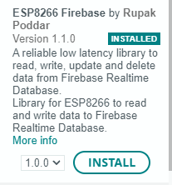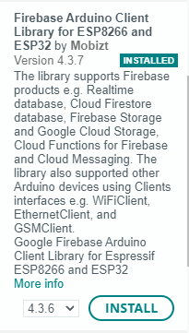

**The following code is uploaded into node MCU:**

#include <ESP8266WiFi.h> // library header file

#include <FirebaseESP8266.h> // library header file

#include <SoftwareSerial.h> //library file for UART communication

#define FIREBASE_HOST "mitapp-2b06f-default-rtdb.firebaseio.com" //Database host

#define FIREBASE_AUTH "rO4y2h9phh8lmH9cxIwQ4lrpqI3u2Z68yYAHHLYC" // Database web API for writing to the database

#define WIFI_SSID "RVAELP021 8857" // Wifi SSID to connect ESP8266

#define WIFI_PASSWORD "rvae@12345" // Wifi password to connect ESP8266

FirebaseData firebaseData;

float total;

float out, out1, out2, out3;

void setup()

{

Serial.begin(9600); // Baud rate for UART communication

randomSeed(analogRead(0));

WiFi.begin(WIFI_SSID, WIFI_PASSWORD);

Serial.print("connecting"); //print on the serial monitor

while (WiFi.status() != WL_CONNECTED)

{

Serial.print(".");

delay(500);

}

Serial.println();

Serial.print("connected: ");

Serial.println(WiFi.localIP());

Firebase.begin(FIREBASE_HOST, FIREBASE_AUTH);

}

void loop()

{

if (Serial.available()) //if anything available in the serial monitor of the other microcontroller

{

float data= Serial.parseFloat();

Serial.print("val= ");

Serial.println(data);

out=data;

Firebase.setFloat(firebaseData, "/voltage0", out); // to send the data to the firebase*/

if (Serial.available()) //if anything available in the serial monitor of the other microcontroller

{

float data1= Serial.parseFloat();

Serial.print("val1= ");

Serial.println(data1);

out1=data1;

Firebase.setFloat(firebaseData, "/voltage1", out1);

if (Serial.available()) //if anything available in the serial monitor of the other microcontroller

{

float data2= Serial.parseFloat();

Serial.print("val2= ");

Serial.println(data2);

out2=data2;

Firebase.setFloat(firebaseData, "/voltage2", out2);

if (Serial.available()) //if anything available in the serial monitor of the other microcontroller

{

float data3= Serial.parseFloat();

Serial.print("val3= ");

Serial.println(data3);

out3=data3;

Firebase.setFloat(firebaseData, "/voltage3", out3);

total= out+out1+out2+out3;

Firebase.setFloat(firebaseData, "/total_volt", total);

}

}

}

}

}

**Connection of micro controller with node MCU:**

Tx of micro controller -> Rx of Node MCU

Rx of micro controller -> Tx of Node MCU

Gnd -> Gnd

The values will trigger to the arduino serial monitor and later gets triggered to the database provided with the credentials in the code.

**MIT App Inventor**

MIT App Inventor is an online platform designed to teach computational thinking concepts through development of mobile applications. Students create applications by dragging and dropping components into a design view and using a visual blocks language to program application behavior.

**MIT App Inventor Overview:**

The MIT App Inventor user interface includes two main editors: the design editor and the blocks editor. The design editor, or designer (see Fig. [1](https://link.springer.com/chapter/10.1007/978-981-13-6528-7_3#Fig1)), is a drag and drop interface to lay out the elements of the application’s user interface (UI). The blocks editor (see Fig. [2](https://link.springer.com/chapter/10.1007/978-981-13-6528-7_3#Fig2)) is an environment in which app inventors can visually lay out the logic of their apps using color-coded blocks that snap together like puzzle pieces to describe the program. To aid in development and testing, App Inventor provides a mobile app called the App Inventor Companion (or just “the Companion”) that developers can use to test and adjust the behavior of their apps in real time. In this way, anyone can quickly build a mobile app and immediately begin to iterate and test.

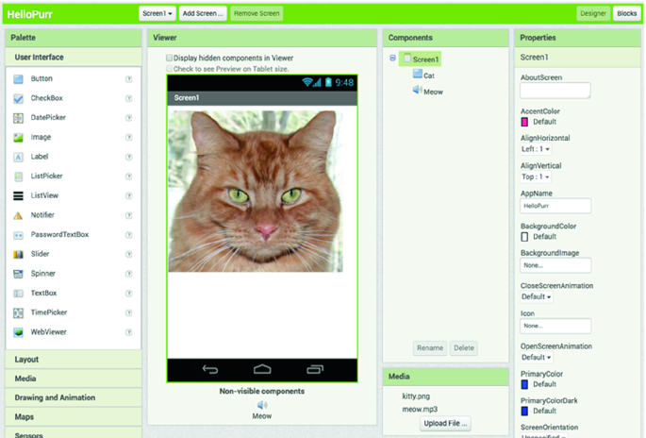

**Fig.1**

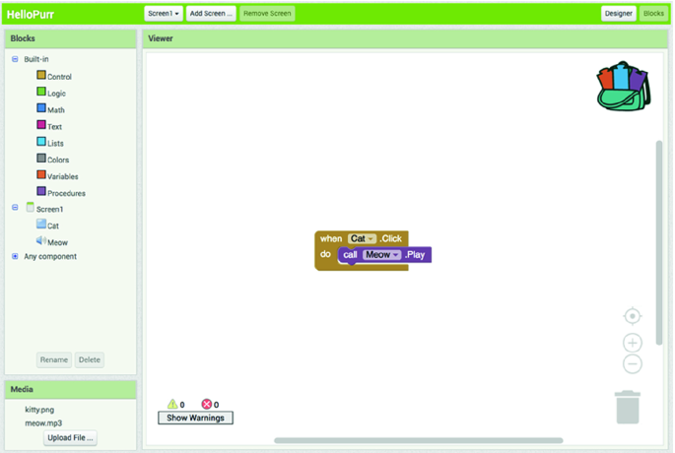

**Fig.2**

This is an interface to create mobile app for any particular application.

**Step1.** For creating a application in MIT app inventor, go to link <http://ai2.appinventor.mit.edu/> > sign in with your Gmail account

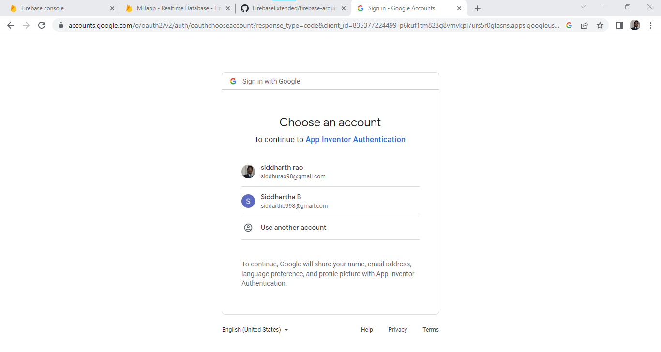

**Step2.** Go to projects> start new project> give a name to the project> Select OK

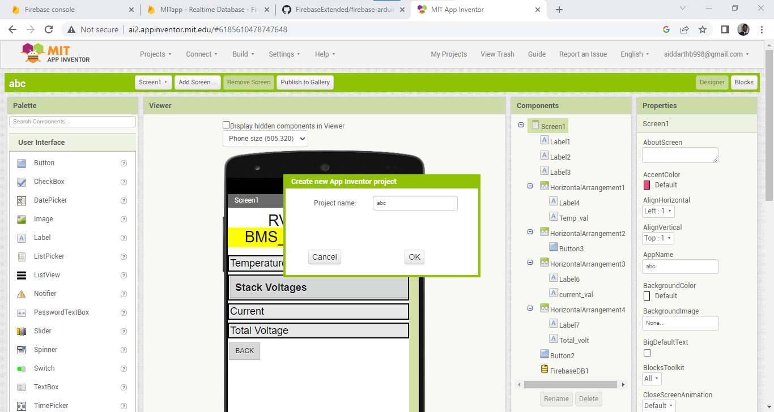

**Step3.** Designing the login screen.

Initially we have to add the firebase database to the components in the right side, Go to experimental on the left side of the interface> under this we can find the firebase DB> add this to the component.

Once we get the select the database > we get the properties of the DB> we have to add the database URL in this.

Design of the first page looks like this

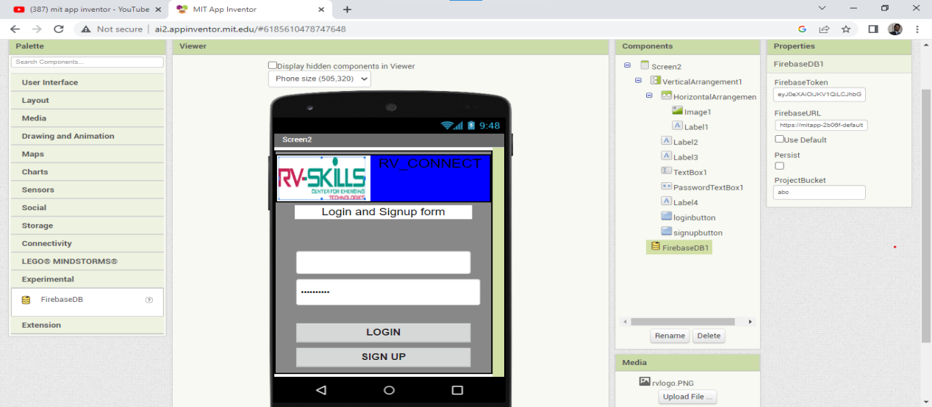

Logic for this:

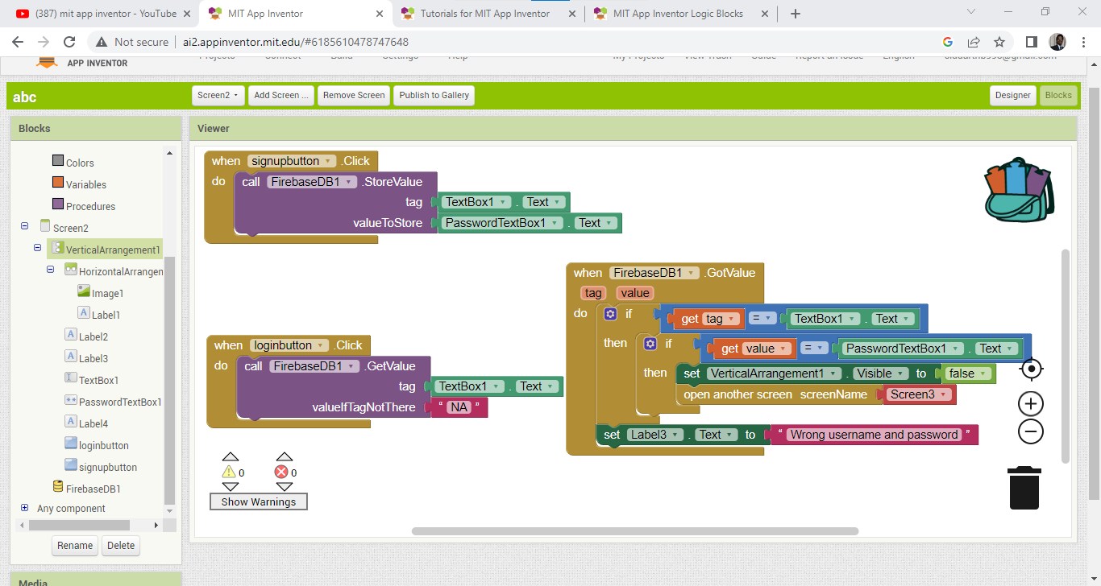

Screen 2 design:

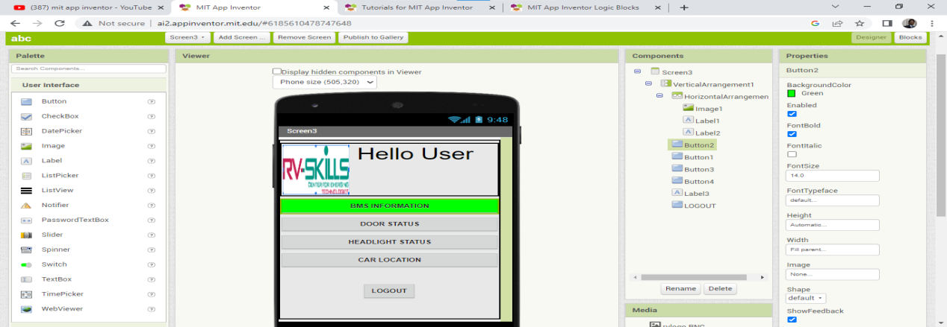

Screen 3 design:

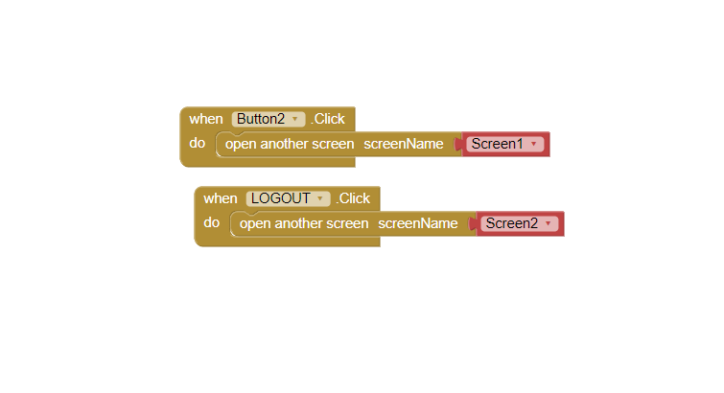

Screen 4 design:

**Step4.**Need to add the database in the screen as we are taking the values from the database.

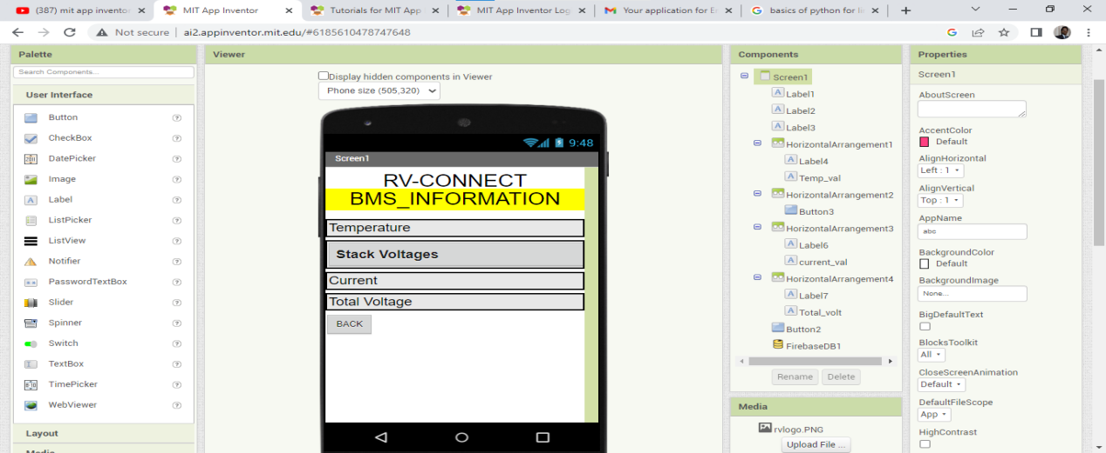

Screen 5 design:

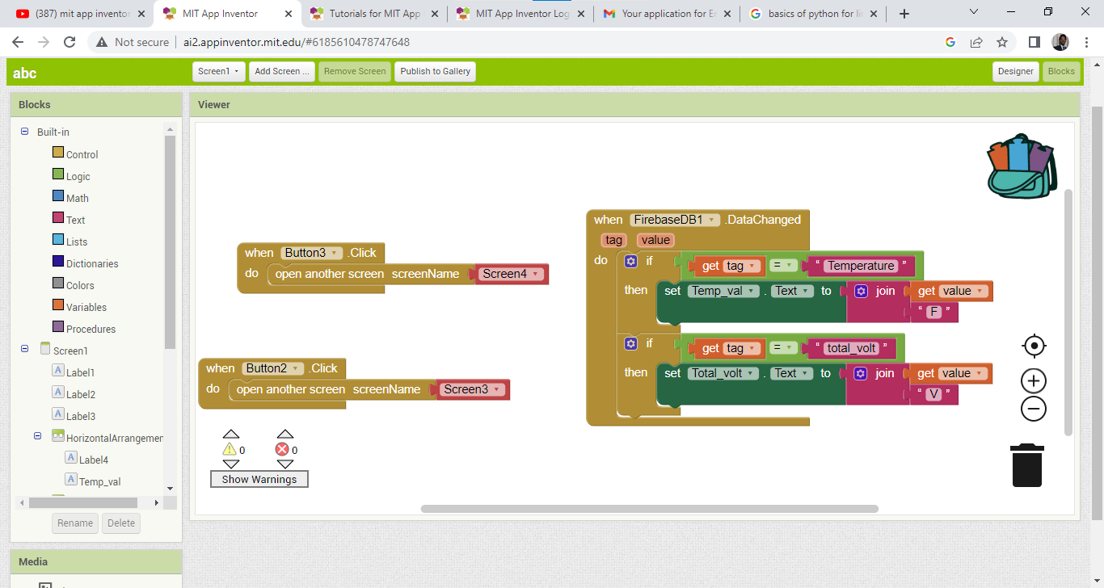

Screen 6 design:

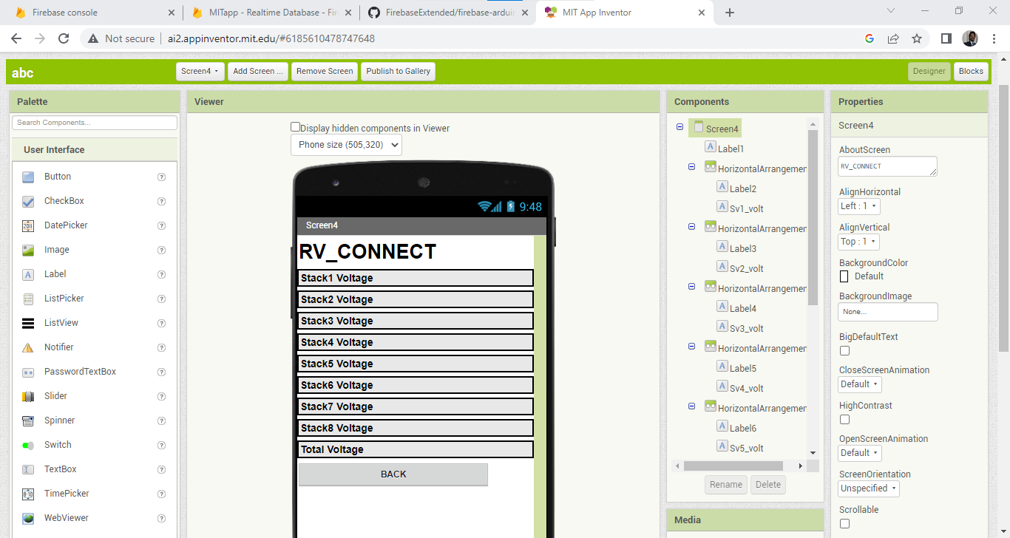

Screen 7 design:

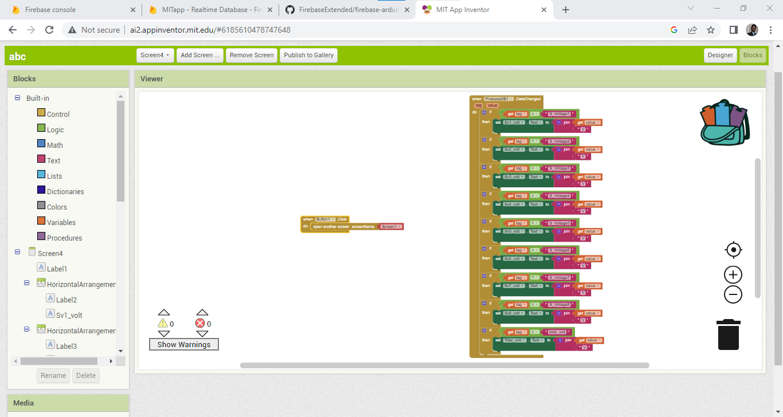

**Coding Standards followed:**

**Code:**

1. Code should be indented.
2. No constants are allowed in the code.
3. All the constants should be #defined.
4. Code should be modular.
5. Code should be well commented.

**Functions/identifies:**

1. All functions should have declarations.
2. Declarations should be in header files.
3. If function declarations are in source file they should appear after #defines.
4. Function names should match with the names in the design document.
5. Lengthy function names should be combined with _.

Ex: battery_pack_voltage ()

1. Every function should be preceded with a header comment describing the task the function performs.

Ex:

/*

Display battery pack voltage

*/

battery_pack_voltage (){

}

**Variables/identifies**

1. All the local variables should be declared in the beginning of the functions.
2. Long variable names should be combined with _.

Ex: voltage_battery_pack

1. The names of the variables should match to the names in the design document.
2. Unless needed variables should have local scope.

**The following code is uploaded into LPC2148:**

#include <lpc214x.h>

#include<stdio.h>

#include<stdlib.h>

#include<string.h>

//Macros

#define VL_SAFE 2.9 //Lower safe operating voltage

#define VU_SAFE 3.65 //Upper safe operating voltage

#define Vref 3.5 //Reference voltage for ADC

#define CB_MIN_DIFF 0.15 //Minimum difference between the max and min voltage desired for cell balancing

#define VL_RANGE 3.5

#define VU_RANGE 3.7

#define D_RELAY 16

#define C_RELAY 17

#define CPIN 18

#define DPIN 19

#define VB_FET_0 20

#define VB_FET_1 21

#define VB_FET_2 22

#define VB_FET_3 23

#define LOW 0

#define HIGH 1

//Global Variables

int Voltage[4];

float v[4];

char msg[100];

int check,CVAL,DVAL;

//Function declarations

void volt(void);

void delay(int);

void sendFloat(void);

void volt_conversion(void);

void UART_Display(int,int);

void init_uart0(void);

void init_uart1(void);

int Check_Voltage(void);

void Discharge(void);

void reset(void);

void io_init(void);

void delay(int count)

{

int i,j;

for(i=0;i<count;i++)

for(j=0;j<5000;j++);

}

void sendMsg() {

int j;

init_uart0();

for(j=0;msg[j]!='\0';j++)

{

while(!(U0LSR & 0x20));

U0THR=msg[j];

delay(100);

}

}

void sendFloat() {

char buffer[32],buff[32];

int i,j,k,l;

init_uart0();

init_uart1();

for(k=3;k>0;k--)

v[k]=v[k]-v[k-1];

for(i=0;i<4;i++)

{

sprintf(buffer, "V%d : %.2f\r\n",i,v[i]);

for(j=0;buffer[j]!='\0';j++)

{

while(!(U0LSR & 0x20));

U0THR=buffer[j];

}

delay(500);

sprintf(buff, "%.2f\r\n",v[i]);

for(l=0;buff[l]!='\0';l++){

while(!(U1LSR & 0x20));

U1THR=buff[l];

}

delay(500);

}

}

void volt_conversion() {

int i;

for(i=0;i<4;i++)

{

v[i]=((Voltage[i]*3.3)/1023)*5;

}

}

void init_uart1(){

PINSEL0|=1<<16;//p0.0 Tx and p0.1 Rx

U1LCR=0x83;

U1DLM=0x00;

U1DLL=0x61;

U1LCR=0x03;

}

void init_uart0() {

PINSEL0|=0x5;//p0.0 Tx and p0.1 Rx

U0LCR=0x83;

U0DLM=0x00;

U0DLL=0x61;

U0LCR=0x03;

}

void volt(void) {

int res;

PINSEL1|=1<<24|0<<25;

PINSEL1|=1<<26|0<<27;

PINSEL1|=1<<28|0<<29;

PINSEL1|=1<<11|0<<10;

while(1) {

AD0CR = 0x00200302;

AD0CR = AD0CR | (1<<24);

while ( !(AD0DR1 & 0x80000000) );

res = (AD0DR1>>6)&0x3FF;

Voltage[0]=res;

AD0CR = 0x00200304;

AD0CR = AD0CR | (1<<24);

while ( !(AD0DR2 & 0x80000000) );

res = (AD0DR2>>6)&0x3FF;

Voltage[1]=res;

AD0CR = 0x00200308;

AD0CR = AD0CR | (1<<24);

while ( !(AD0DR3 & 0x80000000) );

res = (AD0DR3>>6)&0x3FF;

Voltage[2]=res;

AD1CR = 0x00200340;

AD1CR = AD1CR | (1<<24);

while ( !(AD1DR6 & 0x80000000) );

res = (AD1DR6>>6)&0x3FF;

Voltage[3]=res;

volt_conversion();

sendFloat();

}

}

int Check_Voltage(void)

{

volt();

CVAL=(IO1PIN & (1<<CPIN));

DVAL=(IO1PIN & (1<<DPIN));

if(v[0]<=VL_SAFE||v[1]<=VL_SAFE||v[2]<=VL_SAFE||v[3]<=VL_SAFE)||v4<=VL_SAFE||v5<=VL_SAFE||v6<=VL_SAFE||v7<=VL_SAFE)//if any one of stack voltage goes below 2.6V

{

sprintf(msg,"Oops, Battery Low!!! Please plug in the Charger\r\n"); //display low battery!!!

sendMsg();

return 0;

}

else

return 1;

}

/*

Function to turn on cell balancing(CB) FET's

*/

void CB_FET(int a){

switch (a) {

case 0:

IO0SET=1<<VB_FET_0;

break;

case 1:

IO0SET=1<<VB_FET_1;

break;

case 2:

IO0SET=1<<VB_FET_2;

break;

case 3:

IO0SET=1<<VB_FET_3;

break;

}

}

/*

cell balancing function

*/

void Cell_Balancing(void){

sprintf(msg,"\r\nCell balancing function\r\n");

sendMsg();

if((v[0]>v[1])&&(v[0]>v[2])&&(v[0]>v[3]))//&&(v0>v4)&&(v0>v5)&&(v0>v6)&&(v0>v7))

{

while((v[0]>(v[1]+CB_MIN_DIFF))||(v[0]>(v[2]+CB_MIN_DIFF))||(v[0]>(v[3]+CB_MIN_DIFF)))//||(v0>(v4+CB_MIN_DIFF))||(v0>(v5+CB_MIN_DIFF))||(v0>(v6+CB_MIN_DIFF))||(v0>(v7+CB_MIN_DIFF)))

{

CB_FET(0);

volt();

}

}

reset();

if((v[1]>v[0])&&(v[1]>v[2])&&(v[1]>v[3]))//&&(v1>v4)&&(v1>v5)&&(v1>v6)&&(v1>v7))

{

while((v[1]>(v[0]+CB_MIN_DIFF))||(v[1]>(v[2]+CB_MIN_DIFF))||(v[1]>(v[3]+CB_MIN_DIFF)))//||(v1>(v4+CB_MIN_DIFF))||(v1>(v5+CB_MIN_DIFF))||(v1>(v6+CB_MIN_DIFF))||(v1>(v7+CB_MIN_DIFF)))

{

CB_FET(1);

volt();

}

}

reset();

if((v[2]>v[0])&&(v[2]>v[1])&&(v[2]>v[3]))//&&(v[2]>v4)&&(v2>v5)&&(v2>v6)&&(v2>v7))

{

while((v[2]>(v[0]+CB_MIN_DIFF))||(v[2]>(v[1]+CB_MIN_DIFF))||(v[2]>(v[3]+CB_MIN_DIFF)))//||(v2>(v4+CB_MIN_DIFF))||(v2>(v5+CB_MIN_DIFF))||(v2>(v6+CB_MIN_DIFF))||(v2>(v7+CB_MIN_DIFF)))

{

CB_FET(2);

volt();

}

}

reset();

if((v[3]>v[0])&&(v[3]>v[1])&&(v[3]>v[2]))//&&(v[3]>v4)&&(v3>v5)&&(v3>v6)&&(v3>v7))

{

while((v[3]>(v[0]+CB_MIN_DIFF))||(v[3]>(v[1]+CB_MIN_DIFF))||(v[3]>(v[2]+CB_MIN_DIFF)))//||(v[3]>(v[4]+CB_MIN_DIFF))||(v3>(v5+CB_MIN_DIFF))||(v3>(v6+CB_MIN_DIFF))||(v3>(v7+CB_MIN_DIFF)))

{

CB_FET(3);

volt();

}

}

reset();

}

/*

Charging function

*/

void Charge(void)

{

sprintf(msg,"Charging function\r\n");

sendMsg();

check=Check_Voltage();//calling voltage monitoring function to get voltage values

while((CVAL==HIGH)&&(DVAL==HIGH)&&(v[0]<VU_SAFE)&&(v[1]<VU_SAFE)&&(v[2]<VU_SAFE)&&(v[3]<VU_SAFE))//&&(v4<VU_SAFE)&&(v5<VU_SAFE)&&(v6<VU_SAFE)&&(v7<VU_SAFE))//if all stacks are charging below 4V

{

sprintf(msg,"******************************************\r\n\r\n");

sendMsg();

IO1CLR|=1<<C_RELAY;//continue to turn on the gate of charging MOSFET

check=Check_Voltage();

}

reset();

if((v[0]>=VU_SAFE)||(v[1]>=VU_SAFE)||(v[2]>=VU_SAFE)||(v[3]>=VU_SAFE))//||(v[4]>=VU_SAFE)||(v5>=VU_SAFE)||(v6>=VU_SAFE)||(v7>=VU_SAFE))

{

sprintf(msg,"\r\n CELL BALANCING \r\n");

sendMsg();

reset();

Cell_Balancing();

}

if(CVAL==LOW){

IO0SET=1<<C_RELAY;//turn off the gate of charging MOSFET

reset();

}

}

void Discharge(void)

{

sprintf(msg,"\r\nDischarging function\r\n");

sendMsg();

check=Check_Voltage();

if(check==0){

reset();

exit (0);

}

while(CVAL==LOW&&DVAL==HIGH&&v[0]>VL_SAFE&&v[1]>VL_SAFE&&v[2]>VL_SAFE&&v[3]>VL_SAFE){//&&v4>VL_SAFE&&v5>VL_SAFE&&v6>VL_SAFE&&v7>VL_SAFE){

sprintf(msg,"_____________________________________________\r\n\r\n");

sendMsg();

IO1CLR=1<<D_RELAY;//continue to turn on the gate of dis-charging MOSFET

check=Check_Voltage();

if(check==0){

reset();

exit(0);

}

}reset();

}

void io_init(void){

IO1DIR=1<<D_RELAY|1<<C_RELAY|1<<VB_FET_0|1<<VB_FET_1|1<<VB_FET_2|1<<VB_FET_3;

IO1DIR=0<<CPIN|0<<DPIN;

}

void reset(void){

IO1SET=1<<D_RELAY|1<<C_RELAY;

IO1CLR=1<<VB_FET_0|1<<VB_FET_1|1<<VB_FET_2|1<<VB_FET_3|1<<CPIN|1<<DPIN;

}

int main(){

io_init();

reset();

sprintf(msg,"Hello user, have a safe operarion with the BMS%d\r\n",1);

sendMsg();

while(1){

check=Check_Voltage();

if(check==LOW){

reset();

exit(0);

}

CVAL=(IO1PIN & (1<<CPIN));

DVAL=(IO1PIN & (1<<DPIN));

while(CVAL==LOW&&DVAL==HIGH){

sprintf(msg,"Entered discharging while in main\r\n");

sendMsg();

check=Check_Voltage();

if(check==LOW){

reset();

exit(0);

}

Discharge();

}

reset();

check=Check_Voltage();

while(CVAL==HIGH&&DVAL==HIGH&&v[0]<VU_SAFE&&v[1]<VU_SAFE&&v[2]<VU_SAFE&&v[3]<VU_SAFE){//&&v4<VU_SAFE&&v5<VU_SAFE&&v6<VU_SAFE&&v7<VU_SAFE){

Charge();

check=Check_Voltage();

if(((v[0]>=(VU_SAFE))&&(v[1]>=(VU_SAFE))&&(v[2]>=(VU_SAFE))&&(v[3]>=(VU_SAFE))))//&&(v4>=(VU_SAFE))&&(v5>=(VU_SAFE))&&(v6>=(VU_SAFE))&&(v7>=(VU_SAFE))))

{

reset();

IO1SET|=1<<C_RELAY;//turn off the gate of charging MOSFET

sprintf(msg,"Battery Full!!!\r\n");//display battery full

sendMsg();

break;

}

}

if((CVAL==HIGH&&DVAL==HIGH&&((VL_RANGE<v[0])&&(v[0]<VU_RANGE))&&((VL_RANGE<v[1])&&(v[1]<VU_RANGE))&&((VL_RANGE<v[2])&&(v[2]<VU_RANGE))&&((VL_RANGE<v[3])&&(v[3]<VU_RANGE)))){//&&((VL_RANGE<v4)&&(v4<VU_RANGE))&&((VL_RANGE<v5)&&(v5<VU_RANGE))&&((VL_RANGE<v6)&&(v6<VU_RANGE))&&((VL_RANGE<v7)&&(v7<VU_RANGE)))){

reset();

IO1SET|=1<<C_RELAY;;//turn off the gate of charging MOSFET

sprintf(msg,"Battery Full!!! Please remove the charger\r\n");//display battery full

sendMsg();

while(CVAL==HIGH){

CVAL = IO1PIN&(1<<CPIN);

}

}

}

}

**Further enhancement:**

1. Changing the current sequential code into event driven code using interrupts.
2. State of charge (SOC) implementation.
3. State of health (SOH) implementation.
4. Power modes.
5. Geofencing.
6. Geotargeting.
7. Regenerative braking.

**Bill of material:**

|  |  |  |  |
| --- | --- | --- | --- |
| **Materials purchased** | **Quantity** | **Price/unit** | **Total price** |
| Cells, 3.2V, 6A | 24 | 265 | 7505 |
| MOSFET(IRF540) | 10 | 45 | 550 |
| STM32F103RBT6 board | 1 | 2950 | 2950 |
| Voltage Sensors | 8 | 36 | 350 |
| Wattage resistors (10 W) | 20 | 10 | 439 |
| Current sensors (ACS712) | 2 | 107 | 260 |
| Temperature sensors (NTC) | 2 | 20 | 20 |
| 10K ohm, 10W resistors | 4 | 27 | 130 |
| Wires | 2 | 82 | 199 |
| Soldering Iron | 1 | 246 | 299 |
| Soldering flux + solder flux | 1 | 82 | 99 |
| Voltage regulators (IC7805) | 5 | 17 | 100 |
| Node MCU | 1 | 340 | 419 |
|  |  |  | 100 |
|  |  |  |  |
|  |  | Total bill | 13420 |

**Abbreviation used:**

C_ Relay: (Charging Relay).

D_ Relay: (Discharging Relay).

V1, V2...V8: Individual Voltages of the cells.

Vs1, Vs2......Vs8: Voltages read by individual voltage sensors.

Dp: Discharging pin connected at source of C- Relay (refer Detailed Design).

Cp: Charging pin connected at source of D- Relay (refer Detailed Design).

G1, G2.......G8: Output pins connected to the gates of MOSFET’s for cell charge. Dissipation in the cell balancing circuit (refer Detailed Design).